Platoon Robot Project

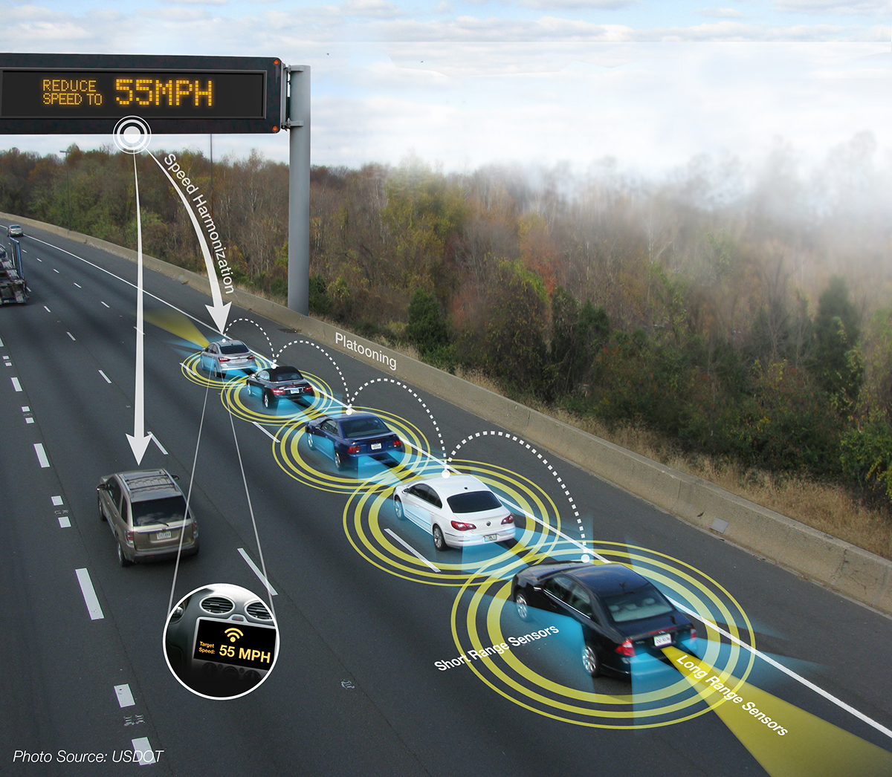

Student name: Mitchell van ‘t Kruys, Farros Ramzy-, Cédric Kruizinga
Teacher: Bakx, René R.P.M., Figaro Oswald
Project: Robot PlatoonProject
Due Date: Tuesday 18th of June 2024
Contents
1. Introduction 3
Objectives 3
Hardware and Software Requirements 3
Hardware: 3
Software: 3
2. Project Phases 4
3. Design 4
State machine design. 4
Flowchart 5
4. Implementation 6
5. Testing 11
Real-Time Feedback Testing 11
PID Testing in MATLAB 11
6. Individual Reflection Student 1: Mitchell van ‘t Kruys 11
Student 2: Farros Ramzy 12
Student 3: Cédric Kruizinga 12
Conclusion 13
Achievements and Learning Outcomes 13
Hardware and Software Integration 13
Testing and Validation 13
Conclusion and Future Directions 13

Revision History

Version | Date | Status | Author | Description | Remarks

Introduction
The Robot Platooning Project is an advanced exploration into the realm of embedded systems and robotics, designed for the third semester of the Embedded Systems class. This project aims to provide a hands-on experience in programming and controlling autonomous robots using embedded microcontrollers, specifically the STM32F303RE NUCLEO board. The primary objective is to develop and implement a platooning system where multiple robots follow a line and maintain a fixed distance from each other using feedback control systems.

Objectives
The main goals of this project are:
- Apply Embedded Systems and Software Development Skills: We will use our knowledge of C/C++ programming, low-level embedded control, timing, interrupts, and feedback-control systems to design and implement a functional robot platooning system.
- Explore IoT Communication (Optional): We will integrate IoT communication to enhance the project, such as using the ESP32 for data transmission to a node-red dashboard.
- Employ a Structured Approach in Project Development: The project promotes a systematic approach to analyze, design, implement, and test the robot systems.

Hardware and Software Requirements
For the successful execution of this project, the following hardware and software components are required:

Hardware:
- STM32 NUCLEO embedded board
FHICT Bot equipped with:
- Two Parallax Feedback 360° High Speed Servos.
- TCRT5000 Tracking Line Follower Sensor.
- ESP32 module for IoT communication.
- Additional components: a back plate (3D printed) and black tape for line following.

Software:
- Development environment for STM32 programming (STM32CubeIDE).
- Software for implementing node-red.

Project Phases
The project is divided into two mandatory phases and an optional third phase:
- Phase 1: Line Following
- Develop a system for the robot to follow a predefined line smoothly and at controlled speeds. The robot should stop when it encounters an obstacle.

- Phase 2: Platooning with Feedback Control Systems
- Implement a PID (Proportional-Integral-Derivative) control system to enable the robot to maintain a fixed distance from a leading robot while following the line.

- Phase 3: Optional Enhancements
- We can choose to add advanced features such as multithreading or IoT communication with a dashboard for a higher grading potential.

Design
For each phase of the project, describe the functional requirements and design approach. Include detailed diagrams and flowcharts to illustrate the system's design and the planned implementation.

State machine design.
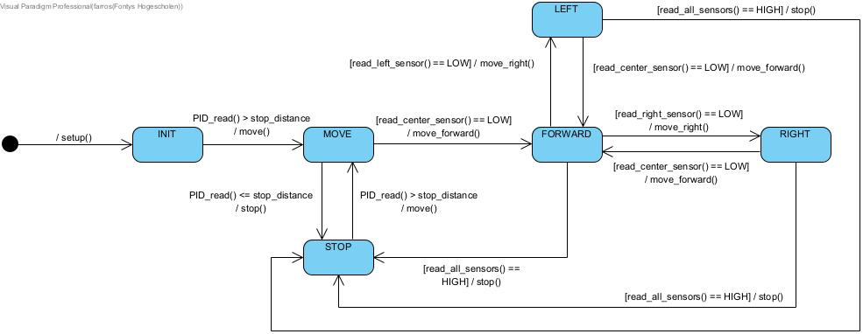

Flowchart
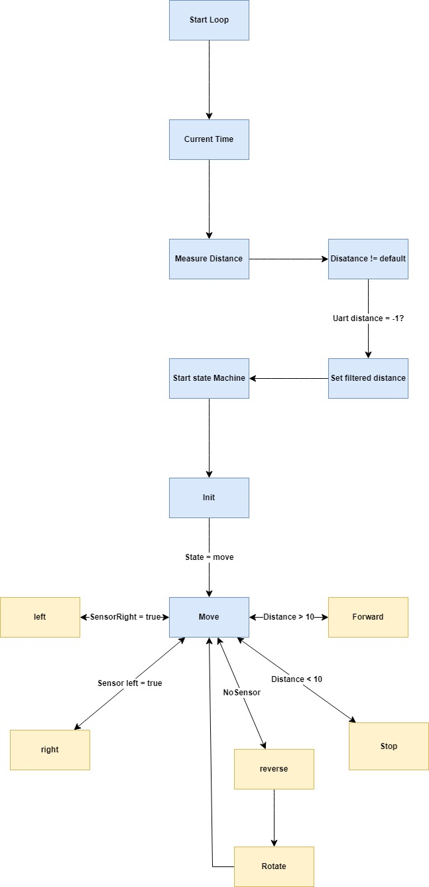

Implementation
Code in phases:
- Phase 1 Setup init code for pins:
Example code for ultrasonic sensor:
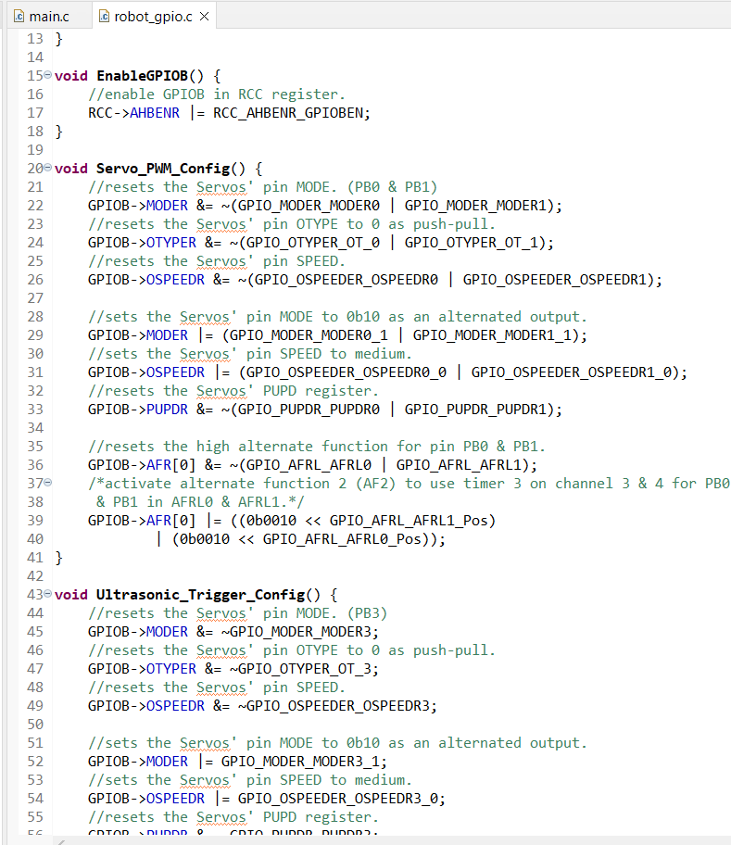

- Phase 2:
Example setting up timers:
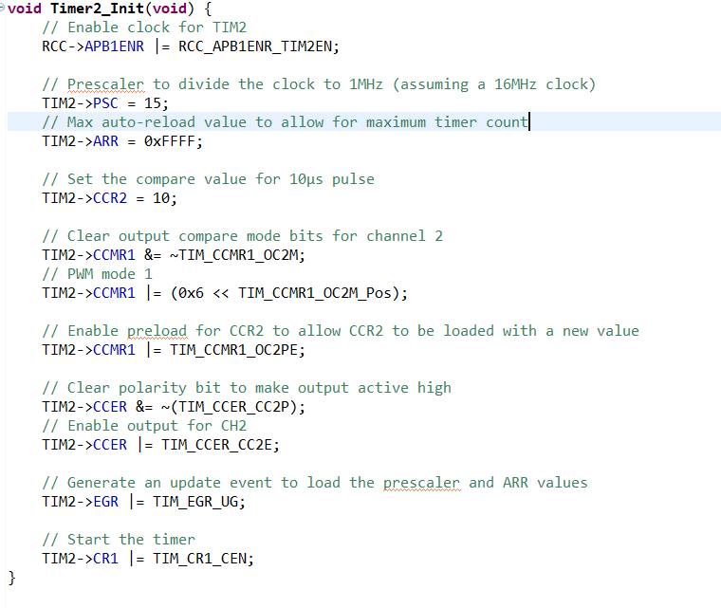

- Phase 3:
Example control of the servo motor:
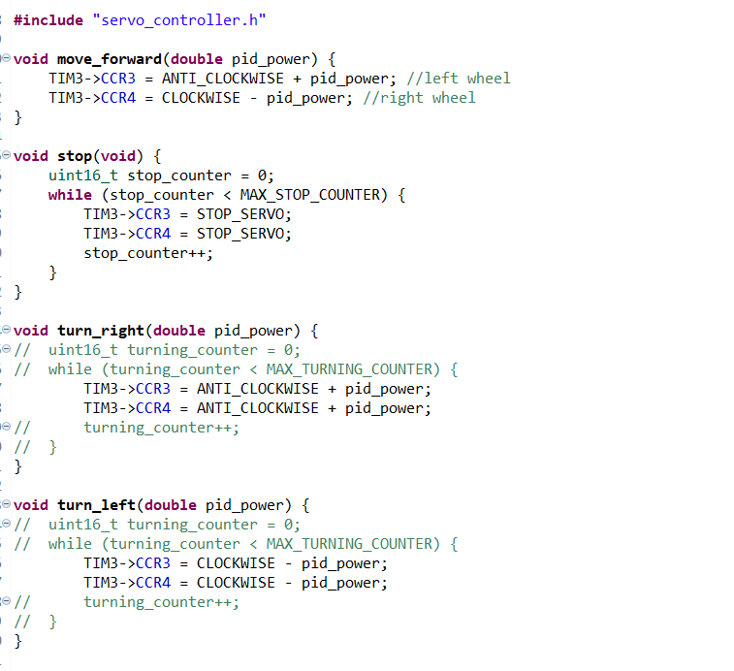
- Phase 4:
Setting up the IR sensors:
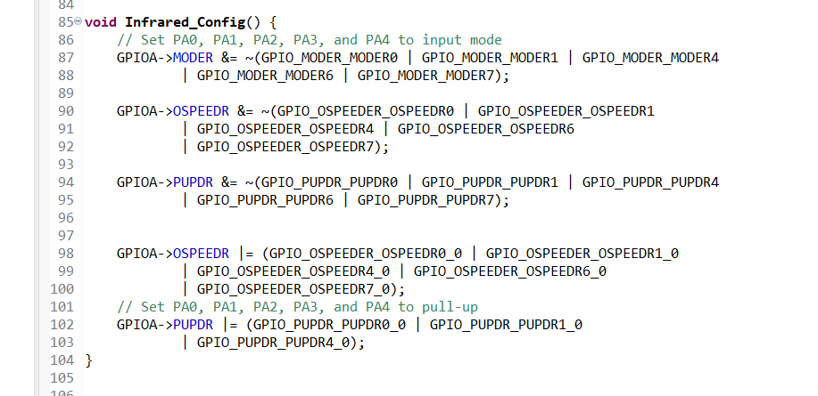

- Phase 5:
Setting up the PID:
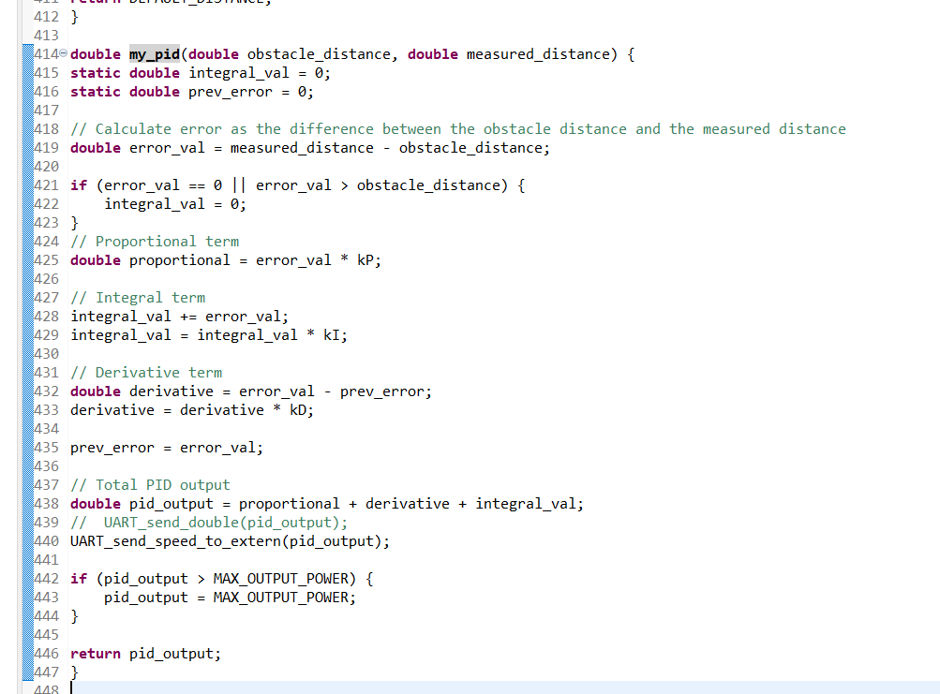

- Phase 6:
Example setting up the state machine:
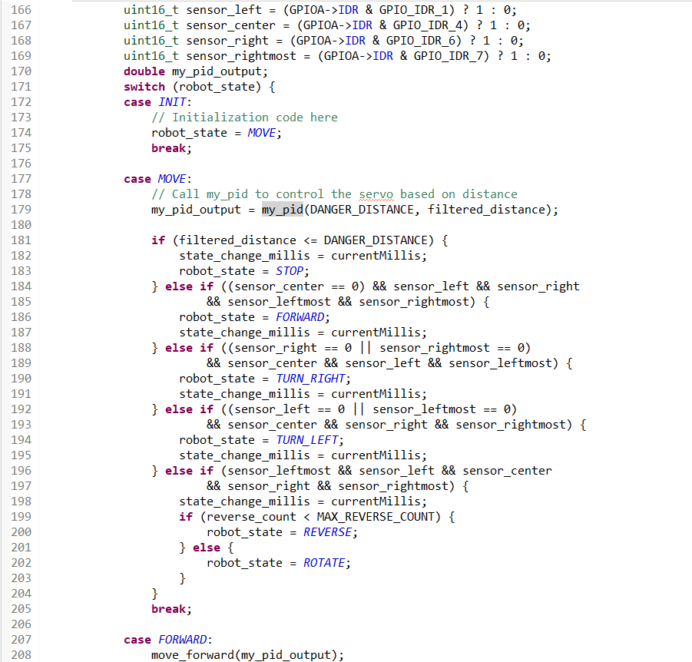

- Phase 7:
example setting up the uart:
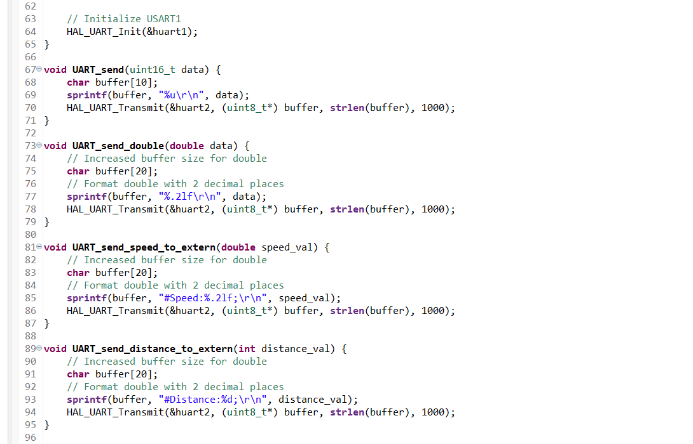
- Phase 8:
Example setting up the node-red + dashboard.
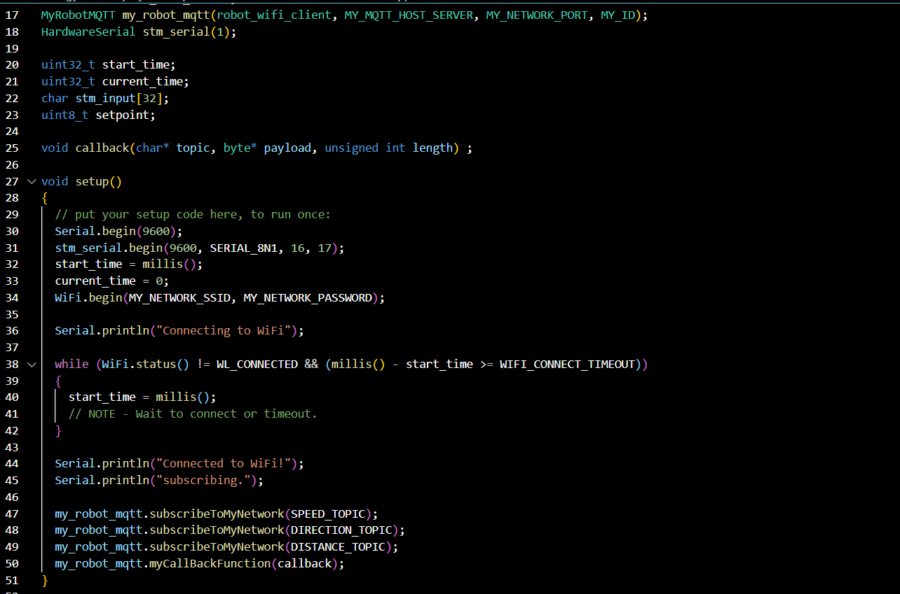
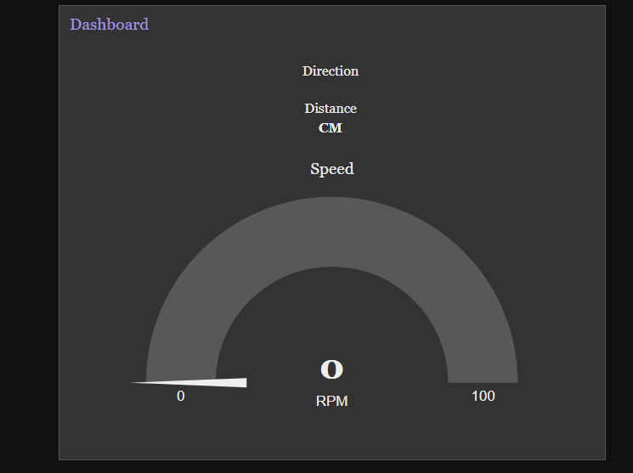

Testing
Throughout the robot platooning project, our testing strategy involved a combination of real-time, hands-on testing and to test and tune the PID we used MATLAB.

Real-Time Feedback Testing
Most of our testing was conducted while actively working with the robot. This involved a continuous process of making adjustments, observing the robot’s behavior, and refining .
Behavioral Observation: By closely monitoring the robot’s actions and reactions, we were able to fine-tune its parameters.
Sensor Data Analysis: We carefully examined the sensor inputs and the robot's corresponding outputs to verify that our control logic was functioning correctly.

PID Testing in MATLAB
In addition to real-time testing, we tuned the PID using MATLAB simulations. This approach allowed us get better values for the PID, which improved the robot’s responsiveness.
Parameter Tuning: Using MATLAB's tools, we were able to optimize the PID parameters before and after deploying them to the robot. This step was important in achieving smooth and stable control of the robot’s servo.

Individual Reflection
Student 1: Mitchell van ‘t Kruys
Contributions
In this project my main contribution was developing the communication between the robot and the node-red dashboard. This included not only setting up the mqtt on node-red but also the uart communication between the devices. I made sure the messages had the correct format for sending and receiving.
Learning Experience
This project was a bit better than previous experiences. This specific platoon project was more fun to design and code than the swarm project. Troubleshooting the robot together with Farros and Cedric was insightful, as they were very helpful in explaining the behavior of the robot, and what parameters changed the behavior.
Challenges and Solutions
The main challenge in this project was setting up the messages between uart and sending it to the node-red dashboard. I did not fully understand uart communication on the stm board, but after testing it with an esp32, I gained more knowledge on this subject.
Future Improvements
For future improvements I would have liked to add remote control as well. I did set up so that both the MCU, could receive and send data/commands. I also setup the node-red dashboard to be able to handle these features, but due to time constraint we couldn’t implement this.
Student 2: Farros Ramzy
Contributions
In this project, I am focusing myself to work on the robot algorithms like how to smoothen the wheel movements with the proper PID values by combining my method to the code that my teammate has, adding methods to read the signal from the infrared sensors to make sure that the robot will always keep on the track and looking for the track in case the robot got derailed, refining the state machine to the robot, and making the UART communication possible to the connected device which will be used as a network access point to connect the robot to the dashboard.
Learning Experience
On this project, I learnt to do an analog read initialization on the STM Nucleo by myself, using the internet as my guidebook since the course did not have the analog read contents in its module.
While testing the infra-red sensor, I found out that the analog read is very accurate than the digital read method. However, using analog read for multiple infra-red sensors create a lot of noise read that make the robot response slower than what was expected.
By this, I learnt that the robot will response much quicker and smoothly on the zig-zag track and sharp turnings if the robot uses the digital read method on the sensors.
However, in an out-of-scope scenario, if the robot is on a track that might change colors, I think, the analog read will be very useful because the infra-red sensor might read different reflective power, depends on the surface and color of the object that the infra-red shoots. And the analog read values can be compared by each other to decides where the robot should be going from that reflective power input.
Challenges and Solutions
There are at least three challenges that I must face while working on this project. The first one is deciding on how to use the infra-red sensor for the track, the second one is improving the PID to make the robot speed up and slow down more smoothly, and the last one is making the state machine to decides where and when the robot must change its speed, how the robot should act on each different obstacles, and what should the robot do before and after it detect the obstacles.
The solution for the infra-red sensor that I have choose is by using the digital read because it works much faster for the robot to response the change of the track and can safe up the very short time the team have to make the robot to be fully worked. If the team have more time to work on this robot, I think an analog read might be better to use for its accuracy and versatility if the track color and texture switches.
For the PID, I decided to use MATLAB method to simulate the speed using that Parallax datasheet from the course module. By using the Simulink MATLAB, I could see the oscillation of the servo wheels on the robot, and I can definitely smoothen the speed changes by doing the proper calculation and using the proper PID values using this simulation result.
As for the state machine, I repaired the design after doing a run up test on the robot and have a look on how the robot acted on the current state, then deciding on how the robot should act next.
Future Improvements
Given more time, I would implement analog read for the infra-red sensors and simplify the state machine so the robot can process its program much quicker and smoothly.

Student 3: Cédric Kruizinga
Contributions
In this project, my primary contributions were in developing the PID controller and enhancing the system’s logic, as well as in testing and troubleshooting. I helped to optimize the steering logic, which significantly improved the robot's performance.
Learning Experience
This project was a valuable learning experience, particularly in terms of collaborating with multiple team members while concentrating on hardware. Troubleshooting the robot was especially enjoyable, as its behaviours were sometimes unexpected but usually straightforward to resolve. This hands-on experience deepened my understanding of real-time problem-solving in a team setting.
Challenges and Solutions
The main challenge I faced was ensuring the PID controller functioned correctly. The documentation provided, "Introduction to PID Controllers," was instrumental in helping me implement the controller for the ES FCS assignment. Despite some necessary tweaks, I successfully integrated the solution. However, the core logic still has room for improvement, as the robot’s movements were not always as smooth or reactive as desired.
Future Improvements
Given more time, I would focus on refining the robot’s reactivity and smoothness. Enhancing these aspects would involve further tuning of the PID controller and possibly redesigning parts of the control and object sensing logic to achieve more precise and fluid movements and improved reactivity.

Conclusion
The Robot Platooning Project has provided a valuable experience in the field of embedded systems and robotics. Throughout our third semester, we have explored the processes of programming and controlling robots using the STM32F303RE NUCLEO board. Our main objective was to develop and implement a platooning system where multiple robots follow a line and maintain a fixed distance using feedback control systems.

Achievements and Learning Outcomes
In this project, we applied our embedded systems and software development skills, particularly in C/C++ programming and low-level control, to create a system capable of autonomous line-following and maintaining a fixed distance in a platoon. We improved the project by integrating IoT communication using the ESP32, which allowed communication to the Node-RED dashboard. Our development was guided by a structured approach involving thorough analysis, design, implementation, and testing.

Hardware and Software Integration
The Robot Platooning Project relied on the integration of the hardware components like the STM32 NUCLEO board, Parallax Feedback 360° High-Speed Servos, TCRT5000 Line Follower Sensor, and the ESP32 module, allowing the robot to effectively follow a line. Our software development was structured into three phases: firstly, we created a line-following system that allowed the robots to navigate a predefined path and handle obstacles. In the second phase, we implemented a PID control system to ensure precise distance maintenance within the platoon, demonstrating our proficiency in advanced control systems. Finally, we implemented optional features, such as IoT communication, which added significant functionality and complexity to the project.

Testing and Validation
Our testing strategy for the Robot Platooning Project was primarily hands-on testing. Through real-time feedback testing, we continuously changed the system based on the robot's behavior. The second test was done in MATLAB, which provides a simulation environment to fine-tune the PID parameters, putting an important basis for achieving stable and responsive control in the implementation.

Conclusion and Future Directions
The Robot Platooning Project was successfully achieved and provided us with valuable understanding. In the future there is a possibility for improving the system further with IoT communication (both ways), multithreading, and additional sensors. Overall, the project offered a highly rewarding experience, offering a mix of technical challenges and learning opportunities.

